**Project Design Phase-II**

**Technology Stack (Architecture & Stack)**

|  |  |
| --- | --- |
| Date: | 29 June 2025 |
| Team ID: | LTVIP2025TMID47029 |
| Project Name: | Enchanted Wings: Marvels of Butterfly Species |
| Maximum Marks: | 4 Marks |

# Technical Architecture

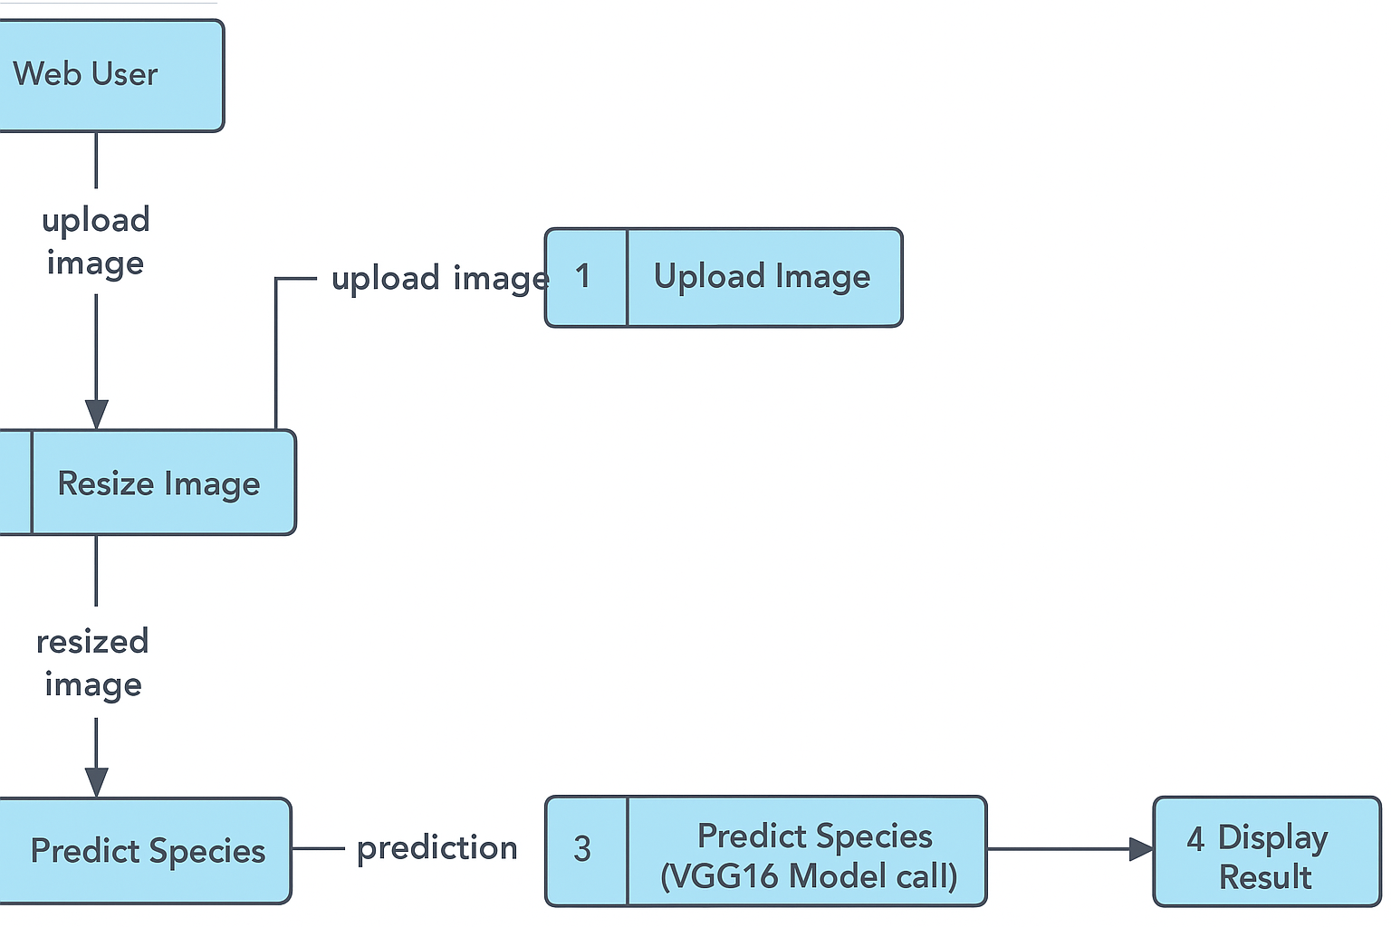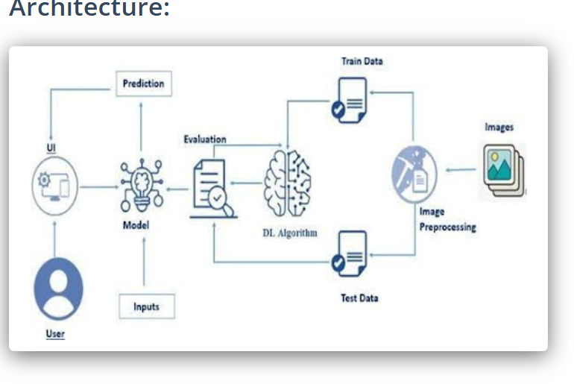The architecture for the Enchanted Wings project integrates image preprocessing, deep learning using transfer learning (VGG16), and a lightweight web interface via Flask. The user uploads an image, which is processed and passed through the model, returning a predicted butterfly species.

## Table-1: Components & Technologies

|  |  |  |
| --- | --- | --- |
| **Component** | **Description** | **Technology** |
| User Interface | Web interface to upload butterfly images | HTML, CSS, Flask |
| Application Logic-1 | Image preprocessing and model loading | Python, NumPy, PIL |
| Application Logic-2 | Butterfly classification using VGG16 model | TensorFlow, Keras |
| Database | Class mappings and logs | JSON / Flat File |
| File Storage | Uploaded image storage | Flask static folder |
| Machine Learning Model | Trained classifier for 75 species | VGG16 + Dense layers |
| Infrastructure | Runs locally or can be deployed on cloud | Localhost / Heroku / PythonAnywhere |

## Table-2: Application Characteristics

|  |  |  |
| --- | --- | --- |
| **Characteristics** | **Description** | **Technology** |
| Open-Source Frameworks | Used for model training and web deployment | TensorFlow, Flask, Keras |
| Security Implementations | Sanitization of filenames and validation of file type | Werkzeug, Flask |
| Scalable Architecture | Modular Flask + model setup allows expansion | Flask Blueprint, Keras model loading |
| Availability | Simple to deploy on any platform | Flask, Gunicorn, Cloud Services |
| Performance | Optimized for fast predictions with low latency | Resizing, batch inference |

# References

https://www.tensorflow.org/

https://keras.io/

https://flask.palletsprojects.com/

https://c4model.com/